|  |  |
| --- | --- |
| **Architetture dei Sistemi di Elaborazione 02GOLOV [GRB-ZZZ]** | Delivery date:  **1st November 2022** |
| **Laboratory**  **3** | Expected delivery of lab_03.zip must include:   * program_1_a.s, program_1_b.s and program_1_c.s * this file compiled and if possible in pdf format. |

Please, configure the winMIPS64 simulator with the *Base Configuration* provided in the following:

* Code address bus: 12
* 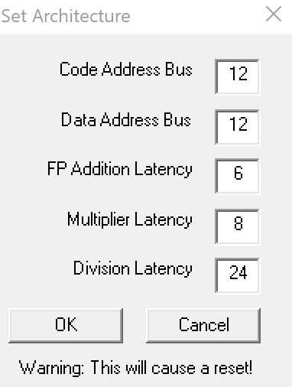Data address bus: 12
* Pipelined FP arithmetic unit (latency): 6 stages
* Pipelined multiplier unit (latency): 8 stages
* Divider unit (latency): not pipelined unit, 24 clock cycles
* Forwarding is enabled
* Branch prediction is disabled
* Branch delay slot is disabled
* *Integer ALU: 1 clock cycle*
* *Data memory: 1 clock cycle*
* *Branch delay slot: 1 clock cycle*.

1. Starting from the assembly program you created in the previous lab called **program_1.s**:

for (i = 0; i < 60; i++){

v5[i] = ((v1[i]+v2[i]) * v3[i])+v4[i];

v6[i] = v5[i]/(v4[i]*v1[i]);

v7[i] = v6[i]*(v2[i]+v3[i]);

}

* + 1. Detect manually the different data, structural and control hazards that provoke a pipeline stall
    2. Optimize the program by re-scheduling the program instructions in order to eliminate as many hazards as possible. Compute manually the number of clock cycles the new program (**program_1_a.s**) requires to execute, and compare the obtained results with the ones obtained by the simulator.
    3. Starting from **program_1_a.s**, enable the *branch delay slot* and re-schedule some instructions in order to improve the previous program execution time. Compute manually the number of clock cycles the new program (**program_1_b.s**) requires to execute, and compare the obtained results with the ones obtained by the simulator.
    4. Unroll 3 times the program (**program_1_b.s**), if necessary re-schedule some instructions and increase the number of used registers. Compute manually the number of clock cycles the new program (**program_1_c.s**) requires to execute, and compare the obtained results with the ones obtained by the simulator.

Complete the following table with the obtained results:

|  |  |  |  |  |
| --- | --- | --- | --- | --- |
| **Program**    **Clock cycle computation** | **program_1.s** | **program_1_a.s** | **program_1_b.s** | **program_1_c.s** |
| **By hand** | 3907 | 3607 | 3547 | 3049 |
| **By simulation** | 3907 | 3607 | 3547 | 3049 |

Compare the results obtained in point 1, and provide some explanation in the case the results are different.

Eventual explanation:

Il simulatore effettua il calcolo dei clock cycle in maniera leggermente differente rispetto a quanto visto a lezione ma, nonostante ciò, il numero di clock cycle calcolati a mano non differisce in quanto la differenza, nel mio codice, sta solo nel fatto che il simulatore effettua il primo stage delle operazioni aritmetiche anche quando il dato non è ancora disponibile e successivamente stalla per un colpo di clock in più rispetto al calcolo a mano.